Spring MVC Framework vs REST

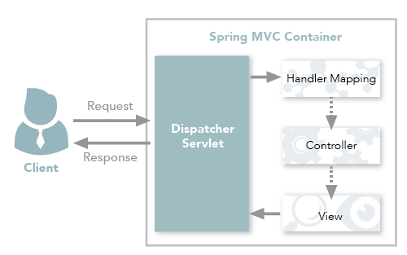

Spring MVC traditional workflow

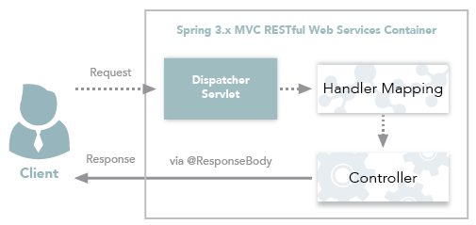

Spring 3.x MVC RESTful web services workflow

